Telecom Bill Generation System
A Minor Project Submitted to

Rajiv Gandhi Proudyogiki Vishwavidyalaya, Bhopal
Towards Partial Fulfillment for the Award of
Bachelor of Technology
(Computer Science and Engineering)

Under the Supervision of  Prof. Aaquib Multani |  | Submitted By  Rahul Chauhan  (0827CS231207)



Department of Computer Science and Engineering
Acropolis Institute of Technology & Research, Indore
July-Dec 2025

EXAMINER APPROVAL

The Minor Project entitled “Telecom Bill Generation System” submitted by Rahul Chauhan (0827CS231207) has been examined and is here by approved towards partial fulfillment for the award of Bachelor of Technology degree in Computer Science Engineering discipline, for which it has been submitted. It understood that by this approval the undersigned do not necessarily endorse or approve any statement made, opinion expressed, or conclusion drawn therein, but approve the project only for the purpose for which it has been submitted.

(Internal Examiner) (External Examiner)
Date: Date:

RECOMMENDATION

This is to certify that the work embodied in this Minor project entitled “Telecom Bill Generation System” submitted by Rahul Chauhan (0827CS231207) is a satisfactory account of the bonafide work done under the supervision of Prof. Aaquib Multani, is recommended towards partial fulfillment for the award of the Bachelor of Technology (Computer Science Engineering) degree by Rajiv Gandhi Proudyogiki Vishwavidhyalaya, Bhopal.

(Project Guide) (Project Coordinator) REPORT

Telecom Bill Generation System Web Application
1. Introduction
The Telecom Bill Generation System is a Python and MySQL-based application designed to automate customer billing. The system stores customer details, calculates billing amounts based on the number of calls made, applies GST, and displays the final payable amount.
It provides two interfaces:
- Command Line
- Tkinter-based GUI

This system eliminates manual work, reduces human errors, and improves billing efficiency.

2. Objectives of the Project
The main objectives of this project are:
- To automate telecom bill calculation.
- To provide an easy-to-use GUI for billing operators.
- To store customer records securely in a database.
- To generate accurate and error-free bills.
- To implement CRUD operations (Create, Read, Update, Delete).
- To ensure persistent storage using MySQL.

3. System Features

3.1 Customer Management
- Add new customer
- Edit customer details
- Delete customer
- Search customer
- View all stored customer records

3.2 Billing Features
- Automatic calculation of bill based on call usage
- GST calculation (10%)
- Printable formatted bill

4. System Architecture
The system follows a three-tier architecture:
Layer | Technology Used
Frontend | Python Tkinter GUI
Backend Logic | Python
Database | MySQL

5. System Requirements

5.1 Software Requirements

Python 3+

MySQL Server & Workbench

mysql-connector library

Tkinter module (preinstalled)

5.2 Hardware Requirements
- 4GB RAM
- Core i3 or above
- 10GB Free Disk Space

6. Implementation Details
Database Table
Field Name | Type
cno | INT (PK)
cname | VARCHAR(50)
mobile | BIGINT
address | VARCHAR(100)
email | VARCHAR(100)
no_calls | INT

7. Billing Formula

- If calls ≤ 100 → Amount = ₹200
- If 101–150 → ₹200 + ₹0.60 × (calls − 100)
- If 151–200 → previous + ₹0.50 × (calls − 150)
- If > 200 → previous + ₹0.40 × (calls − 200)
- GST = 10%
- Net Bill = Amount + GST

- UML Diagrams

  - Use-Case Diagram

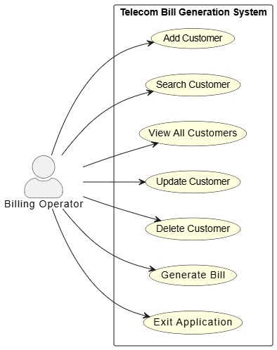

  - ER Diagram

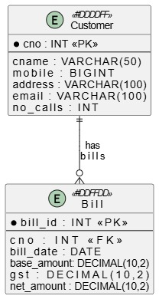

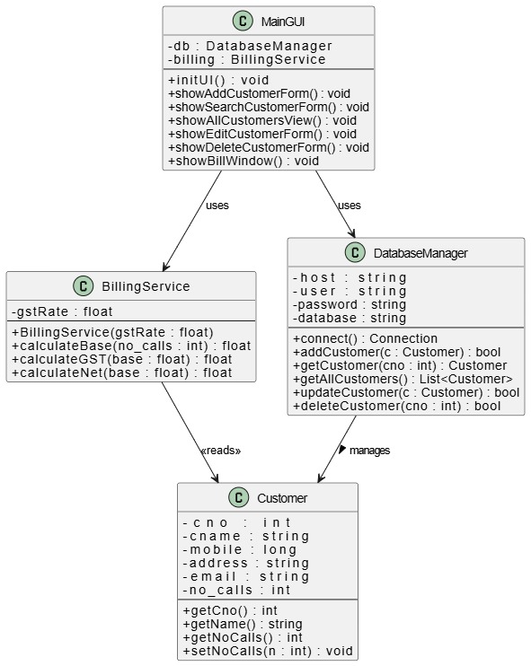
  - Class Diagram

  - Component (Architecture) Diagram
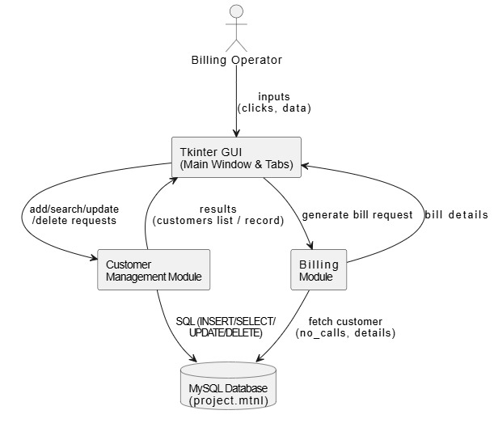

  - Activity Diagram
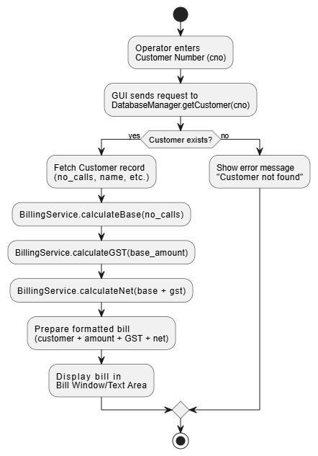

8.6 Sequence Diagrams
Add Customer Sequence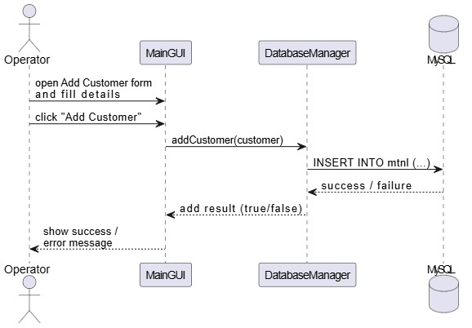

Search Customer Sequence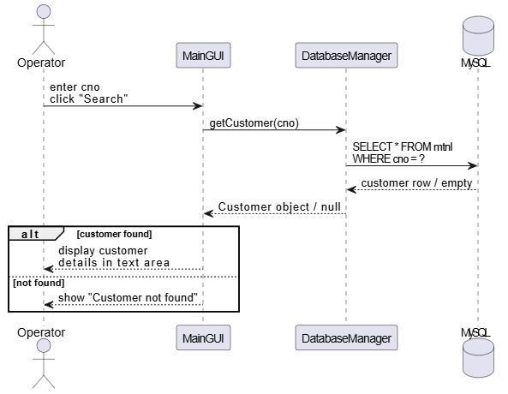
Update Customer Sequence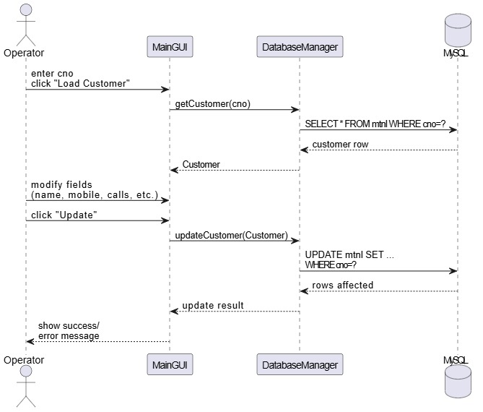

Delete Customer Sequence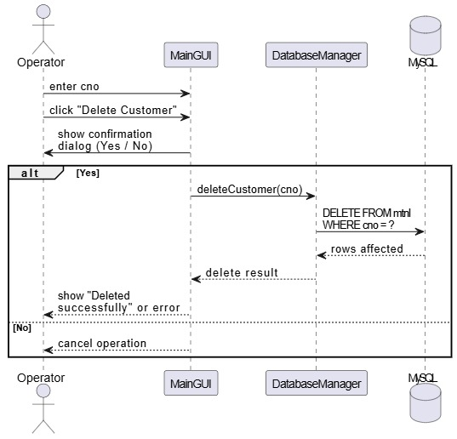

Generate Bill Sequence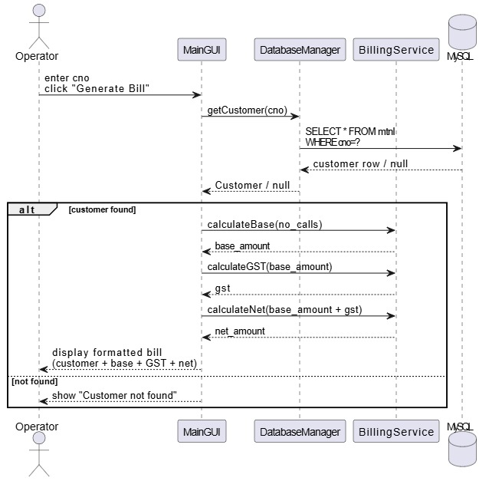

- User Interface Screens

Add Customer
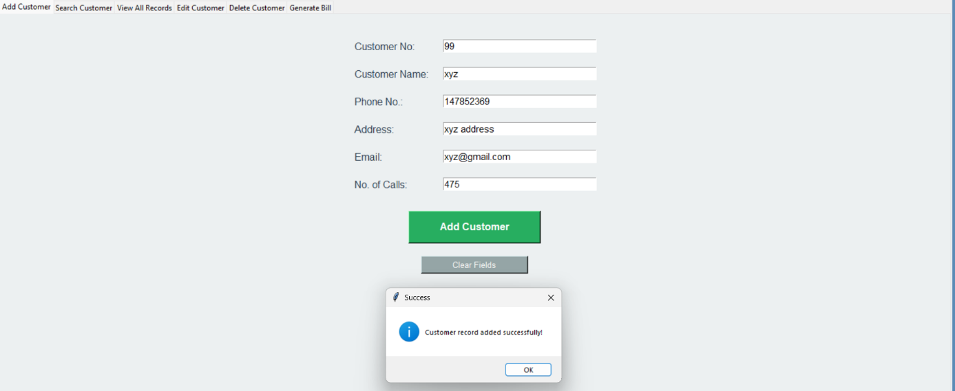

Search Customer
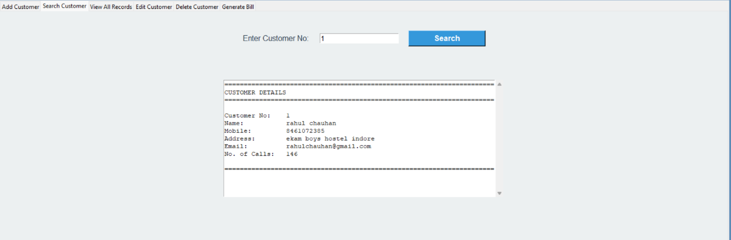

View All Records
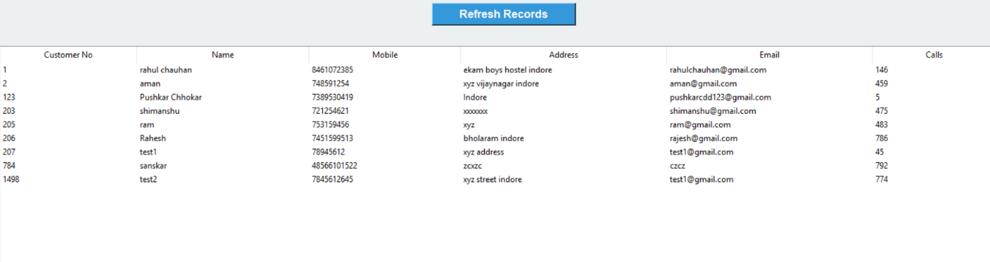

Edit Customer Form
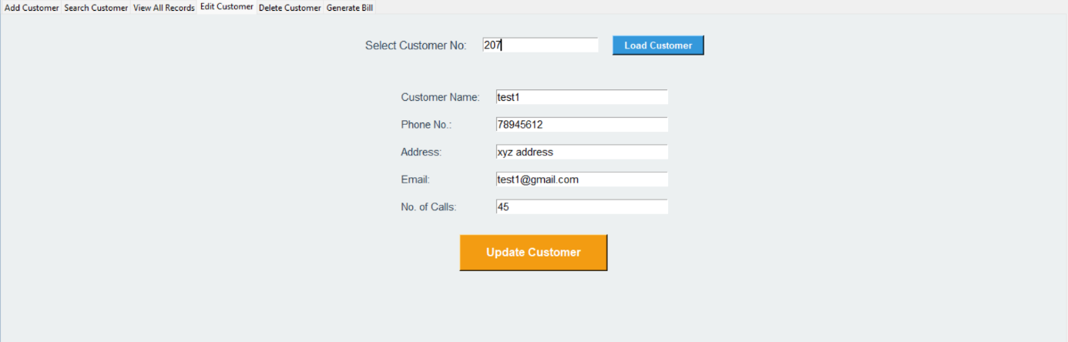

Delete Customer
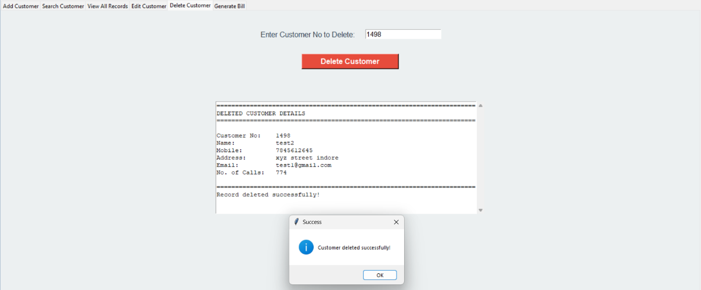

Generate Bill

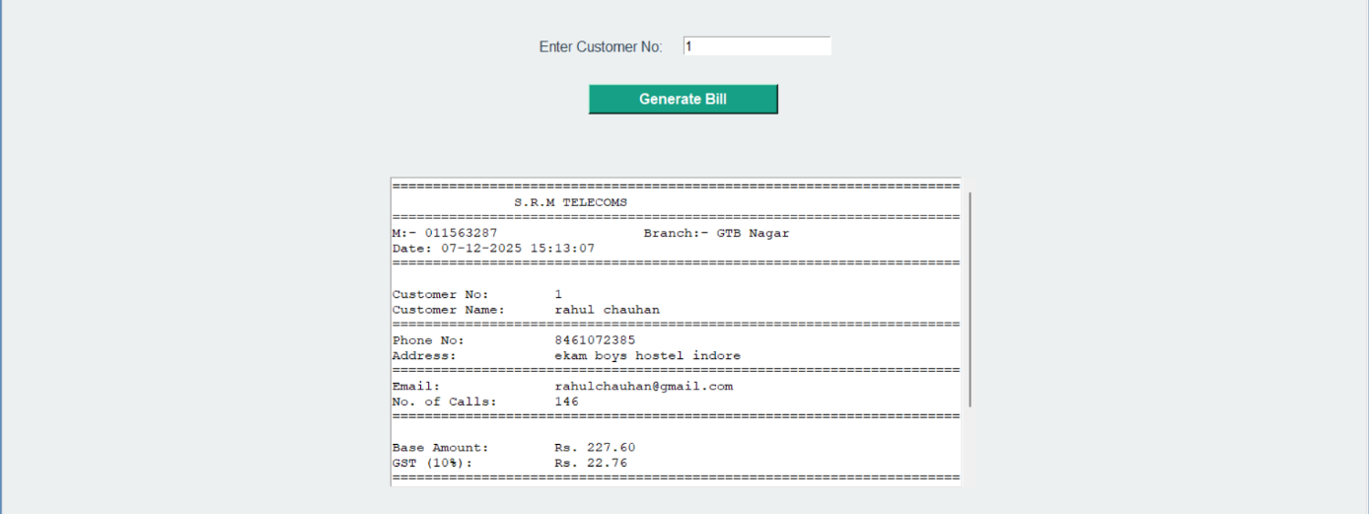
- Results
The Telecom Billing System successfully performs:
- CRUD operations
- Accurate bill generation
- GUI-based interaction
- Database integration

12. Conclusion
This project demonstrates real-world concepts such as database handling, GUI development, and automation. The system reduces manual tasks and enhances billing reliability and consistency.

13. Future Enhancements
- Export bill as PDF
- Add SMS/Email bill delivery
- Cloud deployment
- Multi-user login

14. Bibliography
[1] Python Software Foundation, Python 3 Documentation. [Online]. Available: https://docs.python.org/3/.
[2] Oracle Corporation, MySQL 8.0 Reference Manual. [Online]. Available: https://dev.mysql.com/doc/.
[3] Python Software Foundation, “Tkinter — Python interface to Tcl/Tk,” in Python Standard Library Documentation. [Online]. Available: https://docs.python.org/3/library/tkinter.html.
[4] Oracle Corporation, “MySQL Connector/Python Developer Guide,” in MySQL Connectors and APIs Documentation. [Online]. Available: https://dev.mysql.com/doc/connector-python/en/.
[5] M. Lutz, Programming Python, 4th ed. Sebastopol, CA, USA: O’Reilly Media, 2010.
[6] A. Downey, Think Python: How to Think Like a Computer Scientist, 2nd ed. Needham, MA, USA: Green Tea Press, 2015.
[7] W. J. Brown et al., AntiPatterns: Refactoring Software, Architectures, and Projects in Crisis. New York, NY, USA: John Wiley & Sons, 1998.
[8] R. S. Pressman and B. R. Maxim, Software Engineering: A Practitioner’s Approach, 8th ed. New York, NY, USA: McGraw-Hill, 2014.

